INTRODUCTION TO SPIRITUAL GIFTS

Key Verse:
1 Corinthians 12:7

⁷ But to each one is given the manifestation of the Spirit for the common good.

1. Gifts Given by the Spirit
A. For the Common Good

1 Corinthians 12:1-7

¹ Now concerning spiritual gifts, brethren, I do not want you to be unaware. ² You know that when you were pagans, you were led astray to the mute idols, however you were led. ³ Therefore I make known to you that no one speaking by the Spirit of God says, "Jesus is accursed "; and no one can say, "Jesus is Lord," except by the Holy Spirit.
⁴ Now there are varieties of gifts, but the same Spirit. ⁵ And there are varieties of ministries, and the same Lord. ⁶ There are varieties of effects, but the same God who works all things in all persons. ⁷ But to each one is given the manifestation of the Spirit for the common good.

B. As the Spirit Wills

1 Corinthians 12:8-11

⁸ For to one is given the word of wisdom through the Spirit, and to another the word of knowledge according to the same Spirit; ⁹ to another faith by the same Spirit, and to another gifts of healing by the one Spirit, ¹⁰ and to another the effecting of miracles, and to another prophecy, and to another the distinguishing of spirits, to another various kinds of tongues, and to another the interpretation of tongues. ¹¹ But one and the same Spirit works all these things, distributing to each one individually just as He wills.

2. One Body, Many Parts

A. Every Member Needed

1 Corinthians 12:12-17

¹² For even as the body is one and yet has many members, and all the members of the body, though they are many, are one body, so also is Christ. ¹³ For by one Spirit we were all baptized into one body, whether Jews or Greeks, whether slaves or free, and we were all made to drink of one Spirit.
¹⁴ For the body is not one member, but many. ¹⁵ If the foot says, "Because I am not a hand, I am not a part of the body," it is not for this reason any the less a part of the body. ¹⁶ And if the ear says, "Because I am not an eye, I am not a part of the body," it is not for this reason any the less a part of the body. ¹⁷ If the whole body were an eye, where would the hearing be? If the whole were hearing, where would the sense of smell be?

B. Every Member Placed by God

1 Corinthians 12:18-20

¹⁸ But now God has placed the members, each one of them, in the body, just as He desired. ¹⁹ If they were all one member, where would the body be? ²⁰ But now there are many members, but one body.

3. Gifts Promote Unity and Caring

A. Care for One Another

1 Corinthians 12:21-31

²¹ And the eye cannot say to the hand, "I have no need of you"; or again the head to the feet, "I have no need of you." ²² On the contrary, it is much truer that the members of the body which seem to be weaker are necessary; ²³ and those members of the body which we deem less honorable, on these we bestow more abundant honor, and our less presentable members become much more presentable, ²⁴ whereas our more presentable members have no need of it. But God has so composed the body, giving more abundant honor to that member which lacked, ²⁵ so that there may be no division in the body, but that the members may have the same care for one another. ²⁶ And if one member suffers, all the members suffer with it; if one member is honored , all the members rejoice with it.
B. Serve with Gifts God Gives

²⁷ Now you are Christ's body, and individually members of it. ²⁸ And God has appointed in the church, first apostles, second prophets, third teachers, then miracles , then gifts of healings, helps, administrations, various kinds of tongues. ²⁹ All are not apostles, are they? All are not prophets, are they? All are not teachers, are they? All are not workers of miracles , are they? ³⁰ All do not have gifts of healings, do they? All do not speak with tongues, do they? All do not interpret, do they? ³¹ But earnestly desire the greater gifts.
And I show you a still more excellent way

Prayer requests:
1. People I will intercede for:
______________________________________________________
_________________________________________________________________________________
_________________________________________________________________________________
_________________________________________________________________________________
_________________________________________________________________________________
Other prayer requests:
______________________________________________________
___________________________

Prayer requests:
1. People I will intercede for:
______________________________________________________
_________________________________________________________________________________
_________________________________________________________________________________
_________________________________________________________________________________
_________________________________________________________________________________
Other prayer requests:
______________________________________________________
___________________________

GROW DAILY
INTRODUCTION TO
SPIRITUAL GIFTS
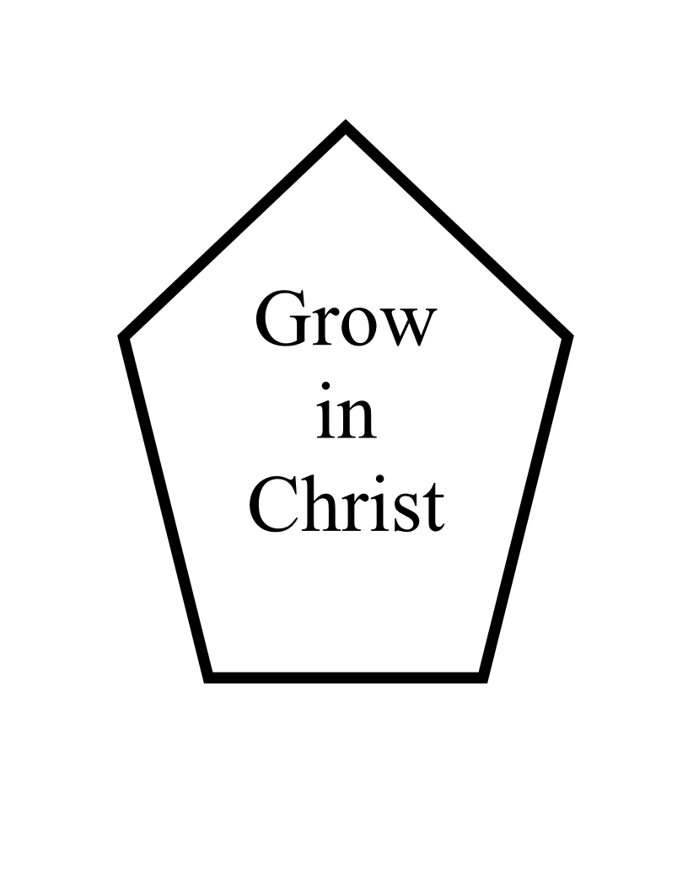
MONDAY:
Set Apart for Ministry
Numbers 1:47-54
TUESDAY:
Empowered to Lead
Judges 6:33-40
WEDNESDAY:
The Blessing of Unity
Psalm 133:1-3
THURSDAY:
Together in the Lord
Acts 2:42-47
FRIDAY:
One in Heart and Mind
Acts 4:32-35
SATURDAY:
Don’t Neglect Your Gift
I Timothy 4:11-16

Calvary Mennonite
Mathis, Texas
Sunday School
Adult English Class
Meets Sundays 10:00 A.M.

You’re invited to grow with us!
April 16-21, 2012

MONDAY:
Set Apart for Ministry
Numbers 1:47-54
Levites Exempted
⁴⁷ The Levites, however, were not numbered among them by their fathers' tribe. ⁴⁸ For the LORD had spoken to Moses, saying, ⁴⁹ "Only the tribe of Levi you shall not number, nor shall you take their census among the sons of Israel. ⁵⁰ "But you shall appoint the Levites over the tabernacle of the testimony, and over all its furnishings and over all that belongs to it. They shall carry the tabernacle and all its furnishings, and they shall take care of it; they shall also camp around the tabernacle . ⁵¹ "So when the tabernacle is to set out, the Levites shall take it down; and when the tabernacle encamps, the Levites shall set it up. But the layman who comes near shall be put to death. ⁵² "The sons of Israel shall camp, each man by his own camp, and each man by his own standard, according to their armies. ⁵³ "But the Levites shall camp around the tabernacle of the testimony, so that there will be no wrath on the congregation of the sons of Israel. So the Levites shall keep charge of the tabernacle of the testimony." ⁵⁴ Thus the sons of Israel did; according to all which the LORD had commanded Moses, so they did.
TUESDAY:
Empowered to Lead
Judges 6:33-40

³³ Then all the Midianites and the Amalekites and the sons of the east assembled themselves; and they crossed over and camped in the valley of Jezreel. ³⁴ So the Spirit of the LORD came upon Gideon; and he blew a trumpet, and the Abiezrites were called together to follow him. ³⁵ He sent messengers throughout Manasseh, and they also were called together to follow him; and he sent messengers to Asher, Zebulun, and Naphtali, and they came up to meet them.
Sign of the Fleece
³⁶ Then Gideon said to God, "If You will deliver Israel through me, as You have spoken, ³⁷ behold, I will put a fleece of wool on the threshing floor. If there is dew on the fleece only, and it is dry on all the ground, then I will know that You will deliver Israel through me, as You have spoken." ³⁸ And it was so. When he arose early the next morning and squeezed the fleece, he drained the dew from the fleece, a bowl full of water. ³⁹ Then Gideon said to God, "Do not let Your anger burn against me that I may speak once more; please let me make a test once more with the fleece, let it now be dry only on the fleece, and let there be dew on all the ground." ⁴⁰ God did so that night; for it was dry only on the fleece, and dew was on all the ground.

WEDNESDAY:
The Blessing of Unity
Psalm 133:1-3
¹ Behold, how good and how pleasant it is For brothers to dwell together in unity! ² It is like the precious oil upon the head,
Coming down upon the beard, Even Aaron's beard,
Coming down upon the edge of his robes. ³ It is like the dew of Hermon
Coming down upon the mountains of Zion;
For there the LORD commanded the blessing—life forever.

THURSDAY:
Together in the Lord
Acts 2:42-47

⁴² They were continually devoting themselves to the apostles' teaching and to fellowship, to the breaking of bread and to prayer.
⁴³ Everyone kept feeling a sense of awe; and many wonders and signs were taking place through the apostles. ⁴⁴ And all those who had believed were together and had all things in common; ⁴⁵ and they began selling their property and possessions and were sharing them with all, as anyone might have need. ⁴⁶ Day by day continuing with one mind in the temple, and breaking bread from house to house, they were taking their meals together with gladness and sincerity of heart, ⁴⁷ praising God and having favor with all the people. And the Lord was adding to their number day by day those who were being saved.

FRIDAY:
One in Heart and Mind
Acts 4:32-35

³² And the congregation of those who believed were of one heart and soul; and not one of them claimed that anything belonging to him was his own, but all things were common property to them. ³³ And with great power the apostles were giving testimony to the resurrection of the Lord Jesus, and abundant grace was upon them all. ³⁴ For there was not a needy person among them, for all who were owners of land or houses would sell them and bring the proceeds of the sales ³⁵ and lay them at the apostles' feet, and they would be distributed to each as any had need.

SATURDAY:
Don’t Neglect Your Gift
I Timothy 4:11-16

¹¹ Prescribe and teach these things. ¹² Let no one look down on your youthfulness, but rather in speech, conduct, love, faith and purity, show yourself an example of those who believe. ¹³ Until I come, give attention to the public reading of Scripture, to exhortation and teaching. ¹⁴ Do not neglect the spiritual gift within you, which was bestowed on you through prophetic utterance with the laying on of hands by the presbytery . ¹⁵ Take pains with these things; be absorbed in them, so that your progress will be evident to all. ¹⁶ Pay close attention to yourself and to your teaching; persevere in these things, for as you do this you will ensure salvation both for yourself and for those who hear you.

Prayer requests:
1. People I will intercede for:
______________________________________________________
_________________________________________________________________________________
_________________________________________________________________________________
_________________________________________________________________________________
_________________________________________________________________________________
Other prayer requests:
______________________________________________________
___________________________

GROW DAILY
INTRODUCTION TO SPIRITUAL GIFTS
MONDAY:
Set Apart for Ministry
Numbers 1:47-54
TUESDAY:
Empowered to Lead
Judges 6:33-40
WEDNESDAY:
The Blessing of Unity
Psalm 133:1-3
THURSDAY:
Together in the Lord
Acts 2:42-47
FRIDAY:
One in Heart and Mind
Acts 4:32-35
SATURDAY:
Don’t Neglect Your Gift
I Timothy 4:11-16

Calvary Mennonite
Mathis, Texas
Sunday School
Adult English Class
Meets Sundays 10:00 A.M.

You’re invited to grow with us!
April 16-21, 2012

GROW DAILY
INTRODUCTION TO SPIRITUAL GIFTS
MONDAY:
Set Apart for Ministry
Numbers 1:47-54
TUESDAY:
Empowered to Lead
Judges 6:33-40
WEDNESDAY:
The Blessing of Unity
Psalm 133:1-3
THURSDAY:
Together in the Lord
Acts 2:42-47
FRIDAY:
One in Heart and Mind
Acts 4:32-35
SATURDAY:
Don’t Neglect Your Gift
I Timothy 4:11-16

Calvary Mennonite
Mathis, Texas
Sunday School
Adult English Class
Meets Sundays 10:00 A.M.

You’re invited to grow with us!
April 16-21, 2012

GROW DAILY
INTRODUCTION TO SPIRITUAL GIFTS
MONDAY:
Set Apart for Ministry
Numbers 1:47-54
TUESDAY:
Empowered to Lead
Judges 6:33-40
WEDNESDAY:
The Blessing of Unity
Psalm 133:1-3
THURSDAY:
Together in the Lord
Acts 2:42-47
FRIDAY:
One in Heart and Mind
Acts 4:32-35
SATURDAY:
Don’t Neglect Your Gift
I Timothy 4:11-16

Calvary Mennonite
Mathis, Texas
Sunday School
Adult English Class
Meets Sundays 10:00 A.M.

You’re invited to grow with us!
April 16-21, 2012

GROW DAILY
Grow Intentionally
MONDAY:
God’s Word is Precious
Psalm 19:7-14
TUESDAY:
Obedience Leads to Understanding
Psalm 119:97-104
WEDNESDAY:
Apply Your Heart to Understanding
Proverbs 2:1-11
THURSDAY:
Understanding Leads to Fruitfulness
Matthew 13:18-23
FRIDAY:
Obedience Brings Blessing
James 1:19-27
SATURDAY:
Born Again by the Word
1 Peter 1:22-25

Calvary Mennonite
Mathis, Texas
Sunday School
Adult English Class
Meets Sundays 10:00 A.M.

You’re invited to grow with us!
March 26-31, 2012

GROW DAILY
INTRODUCTION TO SPIRITUAL GIFTS
MONDAY:
Set Apart for Ministry
Numbers 1:47-54
TUESDAY:
Empowered to Lead
Judges 6:33-40
WEDNESDAY:
The Blessing of Unity
Psalm 133:1-3
THURSDAY:
Together in the Lord
Acts 2:42-47
FRIDAY:
One in Heart and Mind
Acts 4:32-35
SATURDAY:
Don’t Neglect Your Gift
I Timothy 4:11-16

Calvary Mennonite
Mathis, Texas
Sunday School
Adult English Class
Meets Sundays 10:00 A.M.

You’re invited to grow with us!
April 16-21, 2012

1. How does the Holy Spirit determine through whom a gift will be ministered?
____________________________________________________________________________________________________________
2. Why does Paul use the natural body to illustrate the nature of the Church?
_________________________________________________________________________________
3. What determines our value within the Kingdom of God? ______________________________________________________

Prayer requests:
______________________________________________________
___________________________
1. How does the Holy Spirit determine through whom a gift will be ministered?
____________________________________________________________________________________________________________
2. Why does Paul use the natural body to illustrate the nature of the Church?
_________________________________________________________________________________
3. What determines our value within the Kingdom of God? ______________________________________________________

Prayer requests:
______________________________________________________
___________________________
1. How does the Holy Spirit determine through whom a gift will be ministered?
____________________________________________________________________________________________________________
2. Why does Paul use the natural body to illustrate the nature of the Church?
_________________________________________________________________________________
3. What determines our value within the Kingdom of God? ______________________________________________________

Prayer requests:
______________________________________________________
___________________________
1. How does the Holy Spirit determine through whom a gift will be ministered?
____________________________________________________________________________________________________________
2. Why does Paul use the natural body to illustrate the nature of the Church?
_________________________________________________________________________________
3. What determines our value within the Kingdom of God? ______________________________________________________

Prayer requests:
______________________________________________________
___________________________

